Git Init

Creates a new repository within a folder (appears as hidden .git file when view hidden files is enabled).

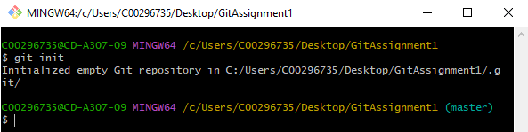

Git Status

Displays the status of files within the folder, such as new files, modified files and files that are added/staged. New/modified files are displayed as red and added/staged files are shown as green.

Git Add

Adds new/modified files to the index and stages them to be committed using the git init command. MUST BE DONE BEFORE COMMIT.

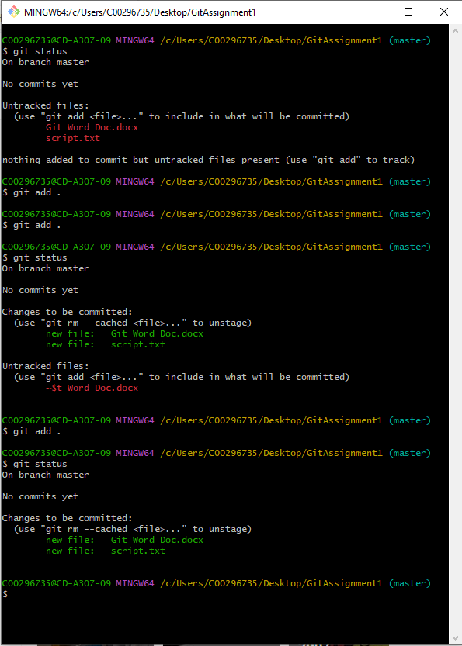

Git Commit

Creates a new commit using the staged files within the index and a log message documenting the changes.

Git Log

Shows the logs within a commit, such as message logs included with a commit command (as shown below).

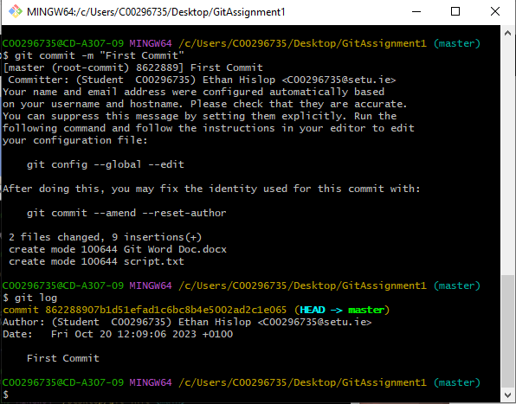

Git Branch

Creates a new branch within the current local repository. You can also use a command to list all the current branches within the current repository.

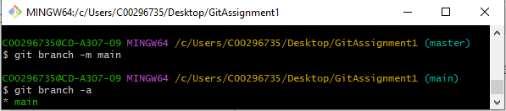

Git Remote

Allows the creation of a remote repository within the current folder. Also allows you to list and delete these remote repositories if necessary.

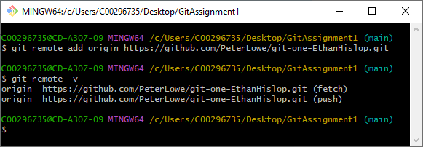

Git Push

Uploads all local commits within the repository/branch to the matching remote repository/branch.